Project Management Guide
Leading Successful Prevention Projects

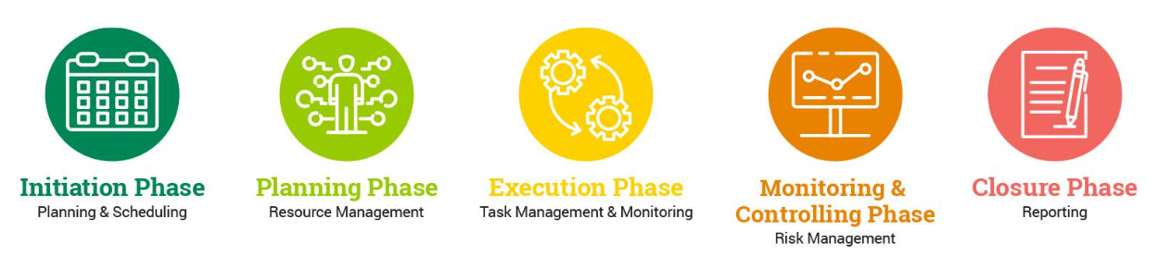

Project Management is the process of developing, planning, executing, and tracking the work of a team to achieve project goals.

This Project Management Guide is designed for schools and organizations taking on a new prevention project, such as implementing a new evidence-based program. Your project manager/team can utilize this guide as a resource as they engage in all five phases of the project life cycle.

Reading through the guide and answering the questions and prompts in each phase will prepare you to manage your new project, apply best practices, and be better equipped to organize, structure, plan, track, and monitor the project. All in all, you will be set up for success as you aim to reach your goal!

Table of Contents
Defining Your Project Team Roles & Responsibilities
The Project Life Cycle at a Glance
The Project Life Cycle Phase 1: Initiation
The Project Life Cycle Phase 2: Project Planning
The Project Life Cycle Phase 3: Project Execution
The Project Life Cycle Phase 4: Project Monitoring and Control
The Project Life Cycle Phase 5: Project Closure
Planning for Project Sustainability
References

Defining Your Project Team Roles & Responsibilities

The Project Manager
The project manager is the individual who organizes and oversees the work required to complete the project, as well as monitors and reports on all project phases.
Use this space to identify your project manager.

The Project Sponsor
The project sponsor is the person, group, or entity funding the project and is a key decision-maker.
Use this space to identify your project sponsor(s).

The Project Stakeholders
Project stakeholders are anyone interested in or affected by the project. Stakeholders are an essential consideration in project management because their actions and decisions can have either a favorable or an adverse influence on the success of a project.
Use this space to identify your project stakeholders. Here are some examples:
- program participants
- youth/young adults
- parents/caregivers
- local businesses
- community members
- school personnel

The Project Team
Project team members are people with different skills and roles who assist in meeting the project’s goals and deliverables.
Use this space to list your project team members, the role(s) they will play, and the skills they demonstrate to support the project’s goals.

The Project Life Cycle at a Glance

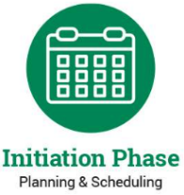 | The Project Life Cycle Phase 1: Project Initiation  - Identify project goals and objectives  - Uncover project risks, constraints, and priorities  - Establish a project scope  - Create a project framework
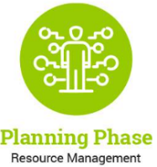 | The Project Life Cycle Phase 2: Project Planning  - Identify and meet with stakeholders  - Set goals, define deliverables, and prioritize tasks  - Create the project schedule  - Identify potential issues and risks  - Develop a communication management strategy
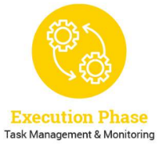 | The Project Life Cycle Phase 3: Project Execution  - Manage people  - Manage processes  - Manage communication
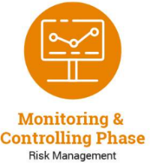 | The Project Life Cycle Phase 4: Project Monitoring and Control  - Establish performance standards  - Monitor changes  - Control changes
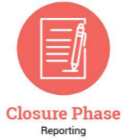 | The Project Life Cycle Phase 5: Project Closure  - Conduct a project performance analysis  - Conduct a team analysis  - Engage in a post-implementation review  - Archive documents

The Project Life Cycle Phase 1: Project Initiation

Identify Project Goals and Objectives
Using the space below, identify project goals and objectives. Consider the following:
- Which program does your community plan to adopt?
- Are you engaging in this process to decrease problems in your community/school? If so, which ones? What evidence do you have to support your belief that these problems exist?

Uncover Project Risks, Constraints, and Priorities
Using the space below, uncover project risks, constraints, and priorities. Consider the following:
- What barriers and challenges might you come across? What steps can you take now to proactively avoid these barriers/challenges?
- Are resources needed (i.e., staff, funding)? List all.

Establish a Project Scope
Using the space below, establish a project scope. Consider the following:
- What are this project’s goals, objectives, deliverables, costs, and deadlines?
- Who does this project serve? Who is this project NOT for?

Create a Project Framework
Using the space below, create a project framework. Consider the following:
- What tools/resources will be used in each phase?
- What is the timeframe for each phase?

The Project Life Cycle Phase 2: Project Planning

Identify and Meet with Stakeholders. Set Goals, Define Deliverables, and Prioritize Tasks.
Using the space below, list the stakeholders you will meet to set goals, define deliverables, and prioritize tasks.

Create the Project Schedule
Using the space below, create a project schedule.

Identify Potential Issues and Risks
Using the space below, identify potential issues and risks.

Develop a Communication Management Strategy
Using the space below, develop a communication management strategy.

The Project Life Cycle Phase 3: Project Execution

Develop a Plan for Managing Project Team Members
Using the space below, develop a plan for managing project team members.

Develop a Plan for Managing Processes
Using the space below, develop a plan for managing processes.

Develop a Communication Plan
Using the space below, develop a communication plan.

The Project Life Cycle Phase 4: Monitoring and Control

Establish Performance Standards
Using the space below, list and describe performance standards.

Monitor Changes
Using the space below, monitor and document expected and actual changes.

Control Changes
Using the space below, make informed decisions regarding the changes listed above.

The Project Life Cycle Phase 5: Project Closure

Project Performance Analysis
Using the space below, provide an analysis of the project performance.

Team Analysis
Using the space below, provide an analysis of the team.

Post-Implementation Review
Using the space below, create questions for a post-implementation review. Track answers in this same space.

Archive Documents
Using the space below, list all documents from team members that should be submitted and stored in a central repository.

Planning for Project Sustainability

Sustaining a project is neither simple nor easy. There are numerous considerations as you strive to maintain consistency — resources, needs, and priorities change. Work with your project team to establish a clear sustainability plan in the table below, outlining the factors that have contributed to the success of your project and how these will be maintained moving forward. Here is a Sustainability Planning Checklist to help your team establish a sustainability plan.
Using the space below, list the factors that contribute to project success.

Using the space below, to describe how project success factors will be maintained going forward.

References

Arenas, Victor. (2018). Project Management Training Module 1 Summary. Retrieved May 1, 2023, from https://www.youtube.com/watch?v=4ygWplMsetk.
Bridges, Jennifer. (2013). Project Planning Process: 5 Steps to Project Management Planning. Retrieved May 1, 2023, from https://www.youtube.com/watch?v=Do8iykQKMfU.
The Digital Project Manager. (2020). Project Management Life Cycle...Explained! Retrieved May 1, 2023, from https://www.youtube.com/watch?v=BIgbwM2ieU8.
The Digital Project Manager, & Aston, B. (2023, March 28). What is the Project Life Cycle: The 5 phases & why it’s still important. The Digital Project Manager. Retrieved May 1, 2023, from https://thedigitalprojectmanager.com/projects/pm-methodology/project-management-life-cycle/
Malherbe, D. (2022, July 15). Project Management: 5 steps and phases. International. Retrieved May 1, 2023, from https://www.teamleader.eu/blog/project-management-5-steps-and-phases.
Patil, J. (2022, March 10). Project Management for Beginners: From Start to Finish. Toggl Blog. Retrieved June 16, 2022, from https://toggl.com/blog/project-management
Project Management Channel. (2022). Activities involved in Project Initiation Phase. Retrieved May 1, 2023, from https://www.youtube.com/watch?v=Mw-zdd3stKw.
Tips for Confident Project Management Collaboration: Project Management Guide. Versatile & Robust Project Management Software. (n.d.). Retrieved May 1, 2023, from https://www.wrike.com/project-management-guide/team-collaboration-tips/
Wedell, Gavin. (2012). What is Project Management? Training Video. Retrieved May 1, 2023, from https://www.youtube.com/watch?v=9LSnINglkQA.

